=Extra questions for hominin evolution

**

Using the diagrams above, explain how tools found with fossilised hominins can indicate their lifestyle.

*Homo erectus* and *Paranthropus robustus* were alive during relatively the same time around 1.5 million years ago. Palaeontologists excavated a skeleton and artefacts from the above time period and were able to classify its species. Describe 4 features that would indicate which species the remains belong to.

Paranthropus

* Sagittal crest
* Large jaw /zygomatic arch /cheekbones / teeth
* Smaller brain – around 560 cc

Homo erectus

* Fire/ hearth
* Tools – made from stone (some descriprion of Acheulian tools)
* Large brain – around 1000cc

Paleontologists have numerous skeletons and artefacts from these species to allow them to infer their lifestyle. Using examples, describe how these discoveries could allow us to make predictions about their lifestyle.

Skeleton

* *Pr* has large teeth, jaw, cheekbones, sagittal crest / smaller cranium/brain
* Indicating strong musculature
* And tough fibrous vegetarian diet
* *He* has smaller teeth, jaw, no sagittal crest,
* softer diet
* large cranium/brain
* Indicating meat / protein
* Broccas and wernickes areas
* Indicate speech

Artefacts

* *Pr* had no tools
* Tools which indicate hunting
* Therefore meat diet
* *He* had hearths /fire
* Cooked food

1. Index fossils are particularly useful in dating fossils due to the fact that they
2. can only be found in one geographic location.
3. were present on earth for a limited period of time.
4. can only be found in the uppermost layers of strata.
5. can provide an absolute date for fossils in the same vicinity.
6. The cranial capacity of *Homo erectus* is in between that of
7. *Homo neanderthalensis* and *Homo sapiens*
8. *Australopithecus* and *Homo habilis*
9. *Homo habilis* and *Homo neanderthalensis*
10. *Australopithecus* and *Homo sapians*

The phylogenetic tree below gives basic evolutionary information about the Hominidae family.

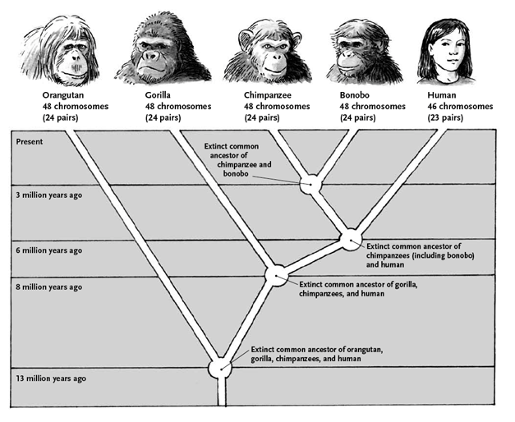

1. Using the information in this phylogenetic tree, which two organisms are most closely related? (1 mark)

_____________________________________________________________

1. Explain how scientists might use protein sequences to develop this phylogenetic tree. (2 marks)

__________________________________________________________________________________________________________________________

1. What is a ubiquitous protein? (2 marks)

__________________________________________________________________________________________________________________________

1. Give an example of a ubiquitous protein. (1 mark)

_____________________________________________________________

**Question 40 (12 marks)**

Complete the table below to show the advances in hominid culture under the headings of tool culture and social culture.

|  |  |  |  |
| --- | --- | --- | --- |
|  | *Homo habilis* | *Homo erectus* | *Neanderthal* |
| Tool Culture |  |  |  |
| Social Culture |  |  |  |